Sreeti Ravi

Jetstream Virtual Machines

1. Quick Start Guide
   1. Accessing JetStream
   2. 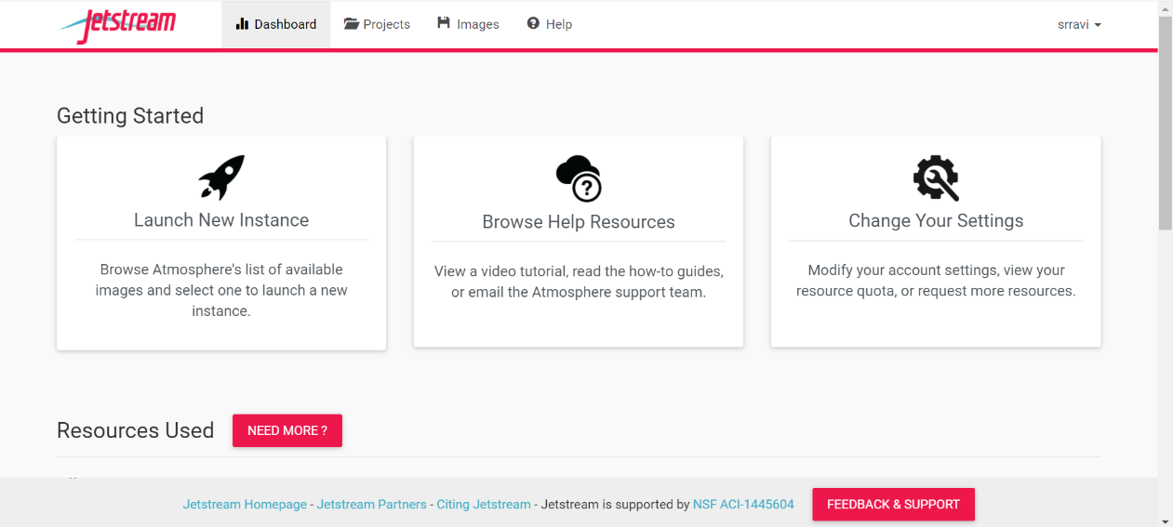Getting Started
   3. Launch an instance

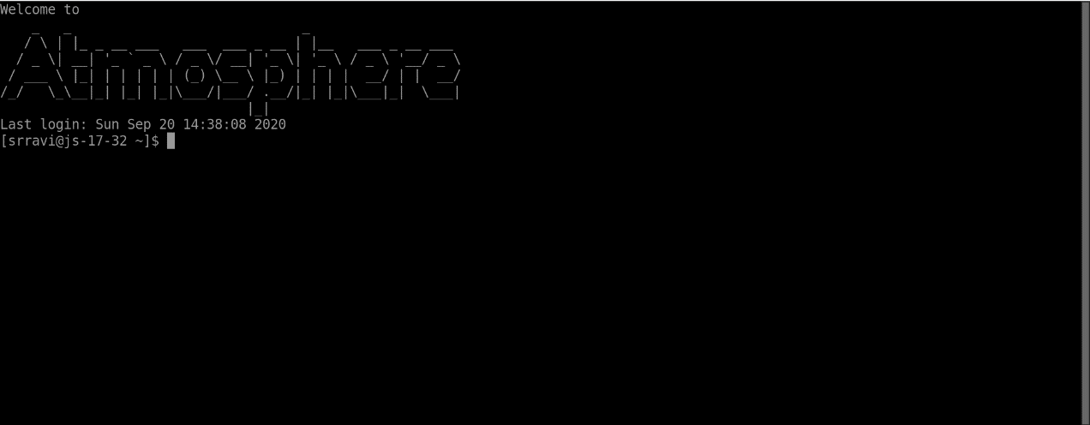

1. System Access
   1. Step-by-step guide

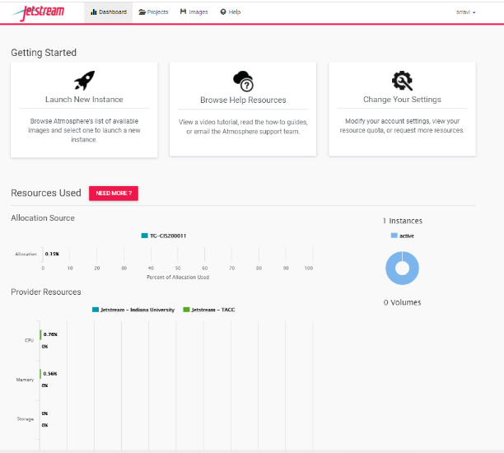

1. SSH keys
   1. Adding SSH keys to the Jetstream Atmosphere environment

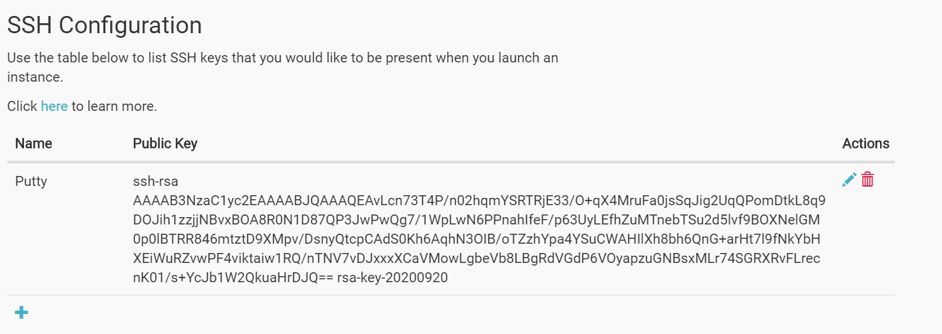

1. Launching your VM

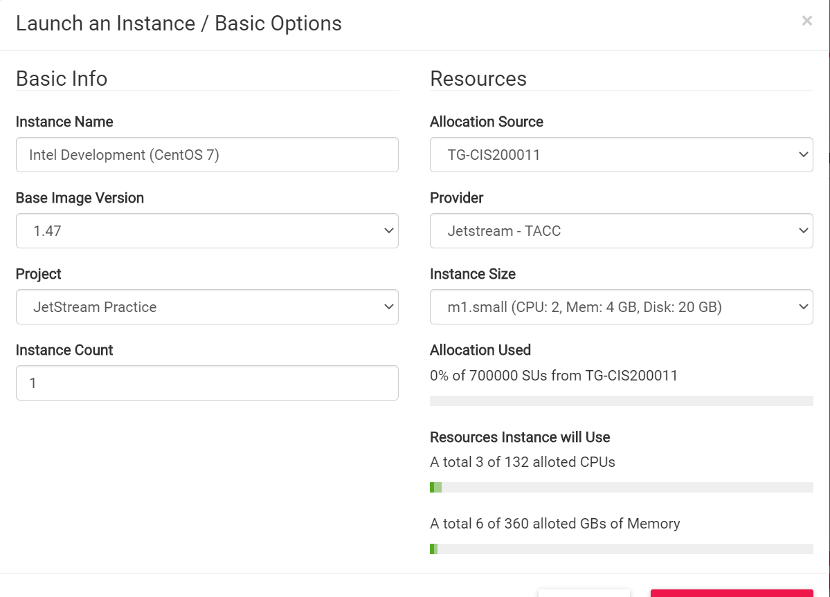

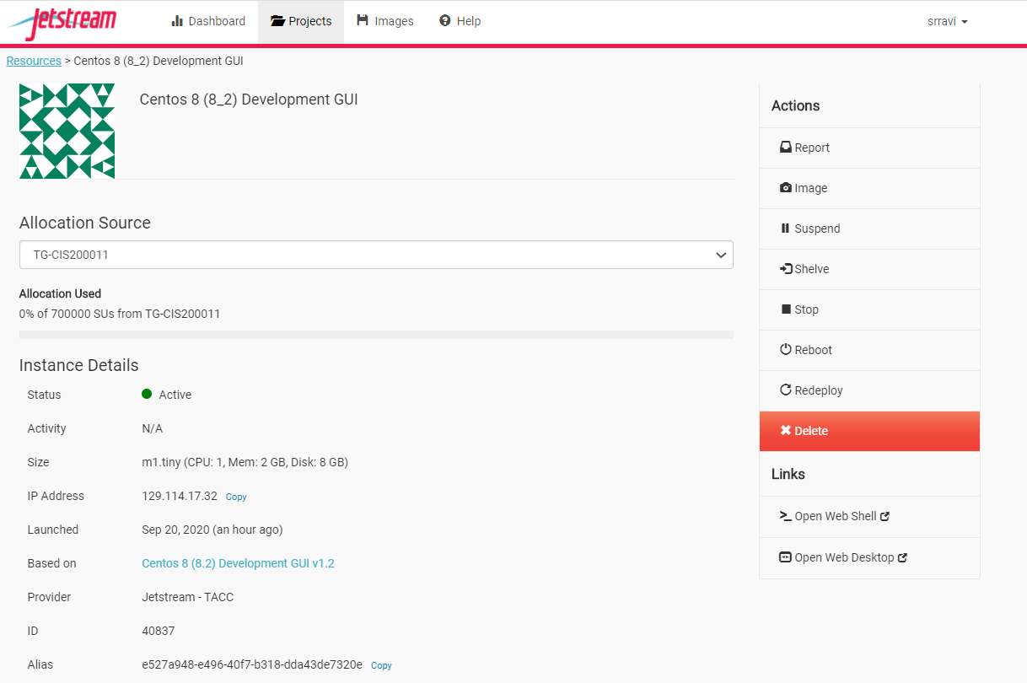

1. Logging into your VM
   1. Logging in with Web Shell

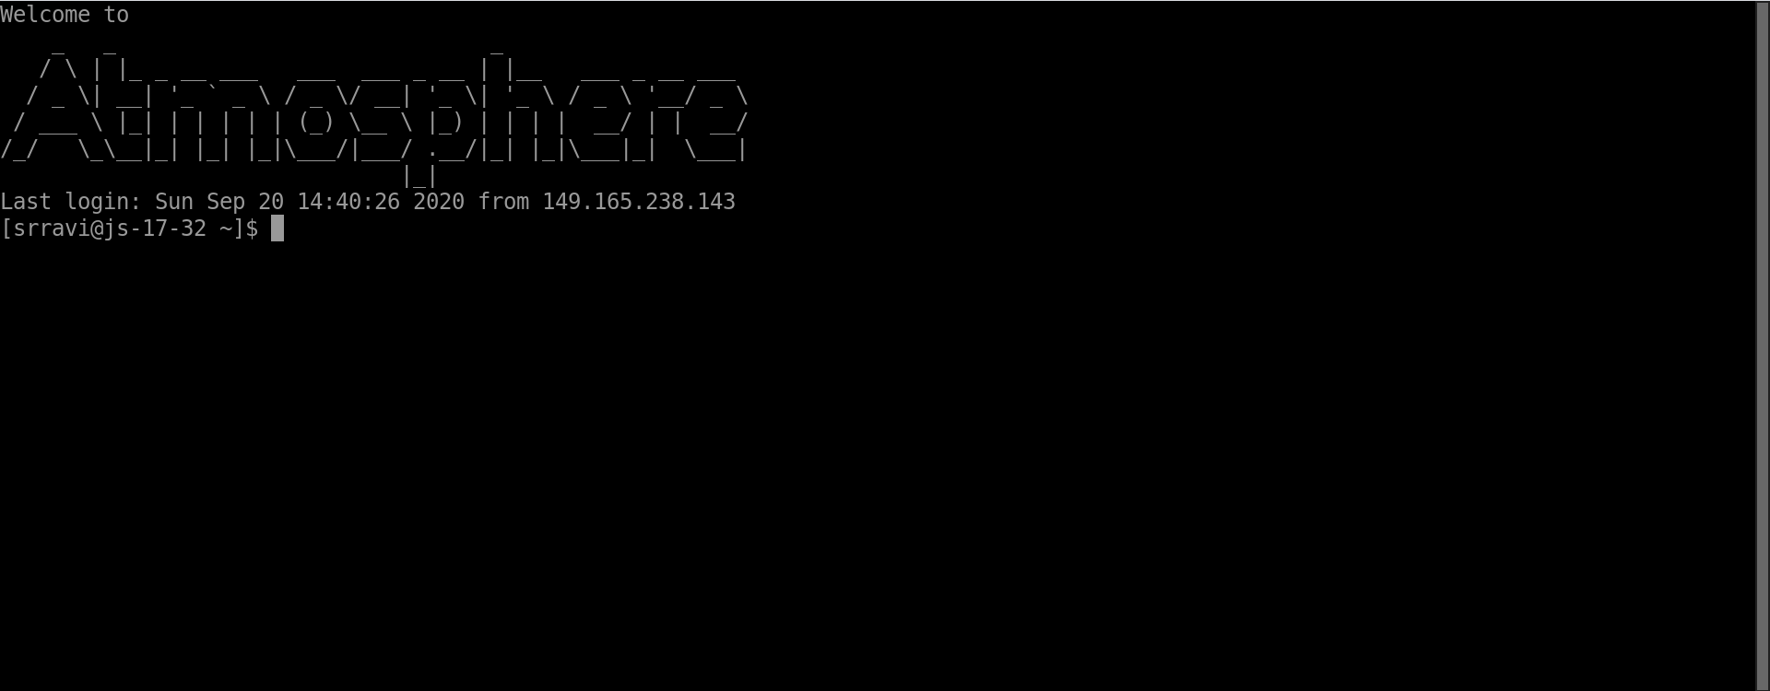

1. Volume
   1. Creating a Volume

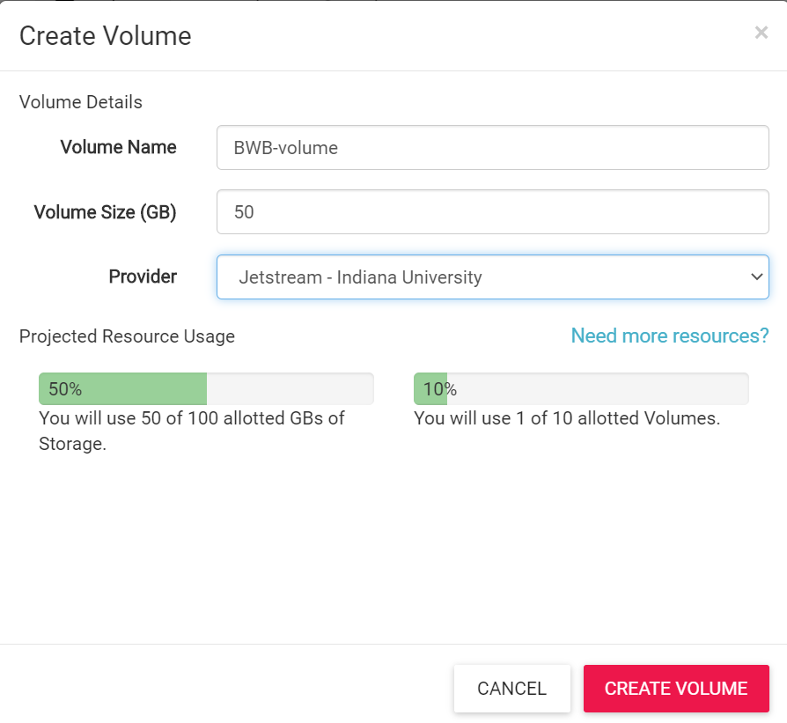

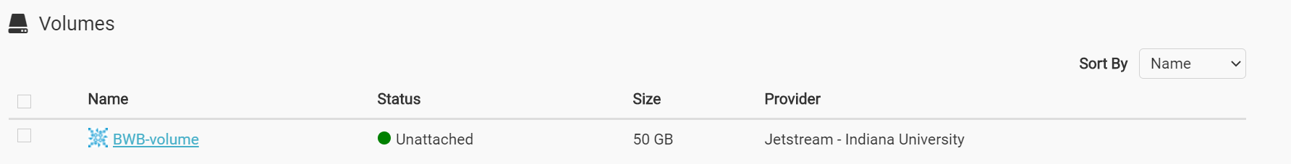

* 1. Attach a volume

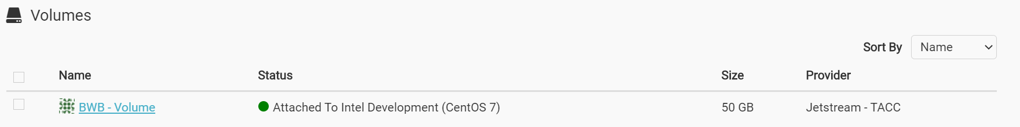

* 1. Detach a volume

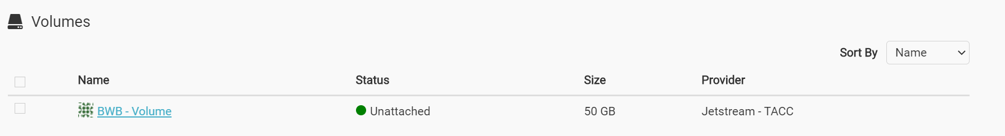

I think Jetstream was a little bit challenging. I had some issues with the SSH connections and I feel like the instructions didn’t fully cover all the issues I was having. I had to look up some stuff on my own to figure out the errors and issues I was having. The other problem was that when I was having issues, the instructions kept giving me links to click on and I felt like I had fallen down a rabbit hole. Other than those issues, I think Jetstream is a good environment with a good mission to let researchers access data analysis resources from anywhere at any time. The environment is easy to use and has a straightforward interface. Compared to Jetstream, I think Google Cloud Platform was easier and simpler to use. I think the instructions were more straightforward as well. I liked how it was more interactive and had questions and quick checks in between so you couldn’t get lost or move on until a certain part was done.